The Front Page of the college is shown in Figure 7.1. Here we can login into the Student and TPO (placement officer) dashboard.

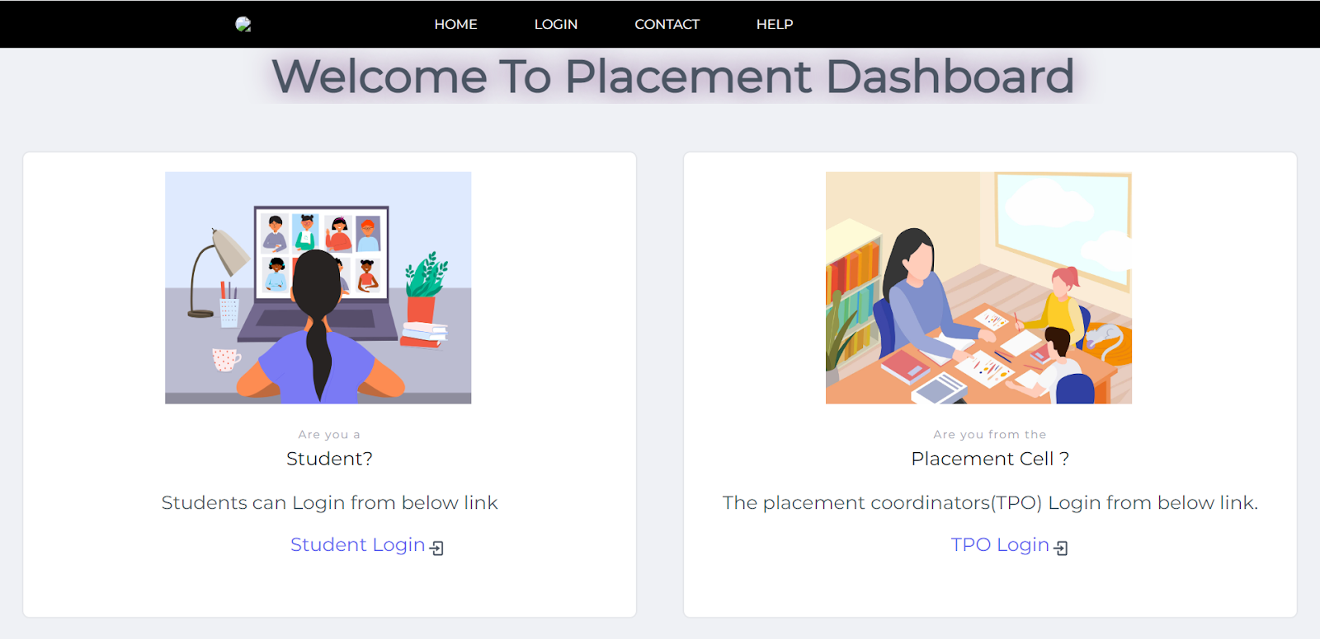

**Fig 7.1** Front Page for College Placement Portal

Figure 7.2 shows the login page for the college placement site. Students can access the portal using their credentials.

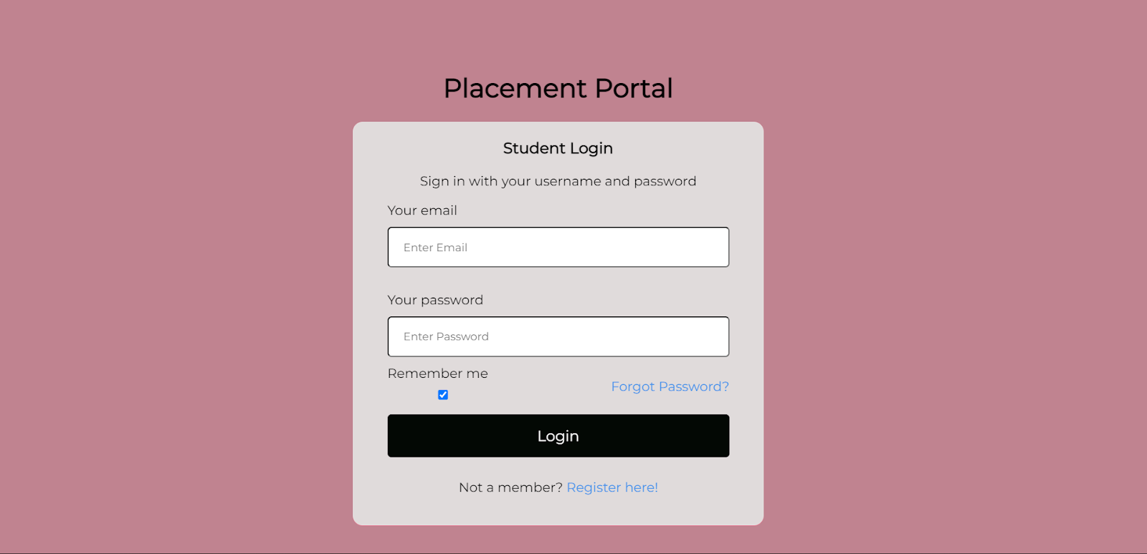 **Fig 7.2** Student Login Page

The Student Dashboard is shown in figure 7.3. This dashboard shows in which company students logged in have been placed.

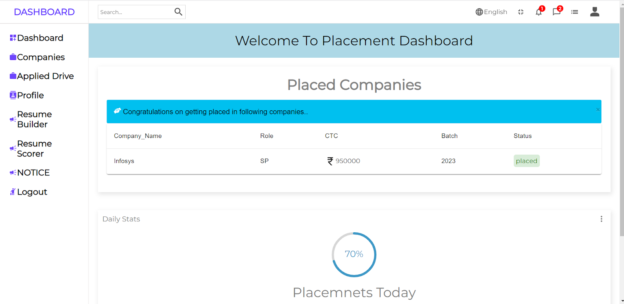

**Fig 7.3** Student Dashboard

Figure 7.4 shows the available/active company on the campus. Students can apply to the company using the view button.

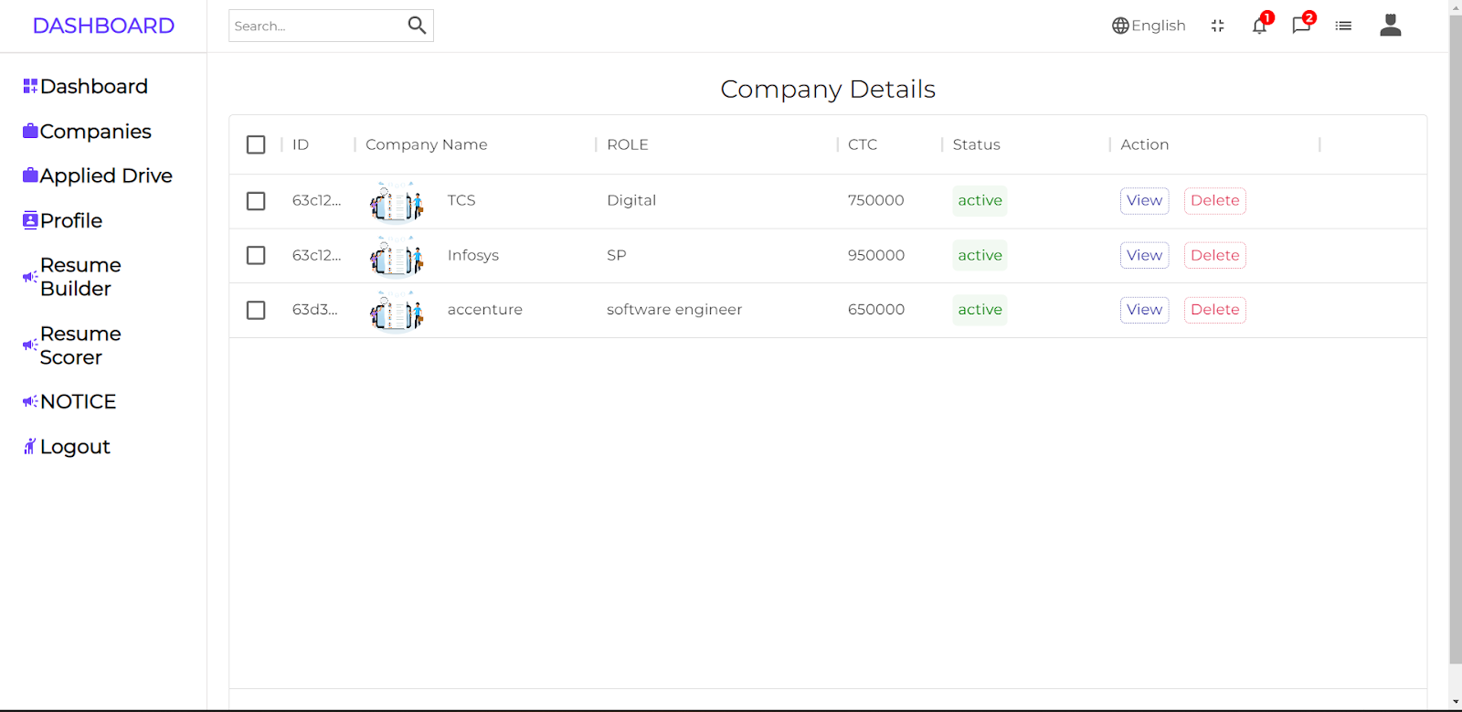

**Fig 7.4** Active Drives of Companies

Figure 7.5 shows the Student Logged in Profile. Students can update their resume before applying to companies.

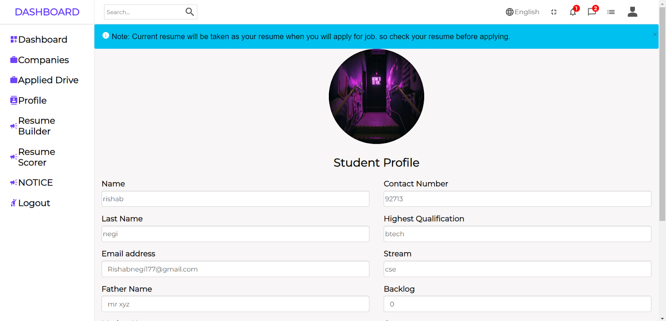

**Fig 7.5** Student Profile

Figure 7.6 shows Resume Builder where students can make their resume for the drives of the companies.

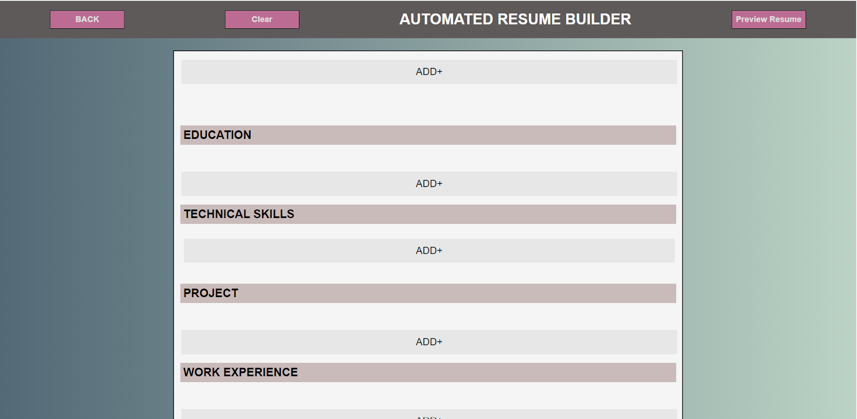

**Fig 7.6** Resume Builder

Resume Scorers have been shown in figure 7.7. Students can upload their resume and see the score of resumes which helps students to pass the ATS (Applicant Tracking System).

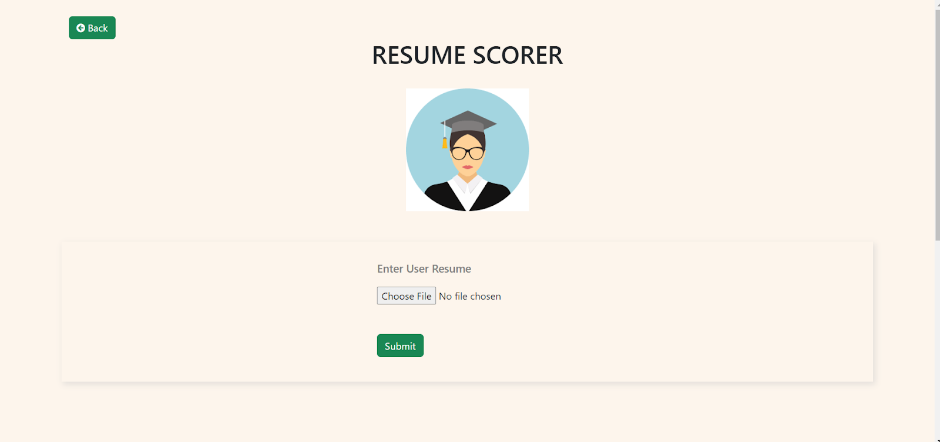

**Fig 7.7** Resume Scorer

Students can select the company as shown in Figure 4. On clicking the apply button we can apply to this company as well as can check whether we are eligible for the drive or not as shown in figure 7.8.

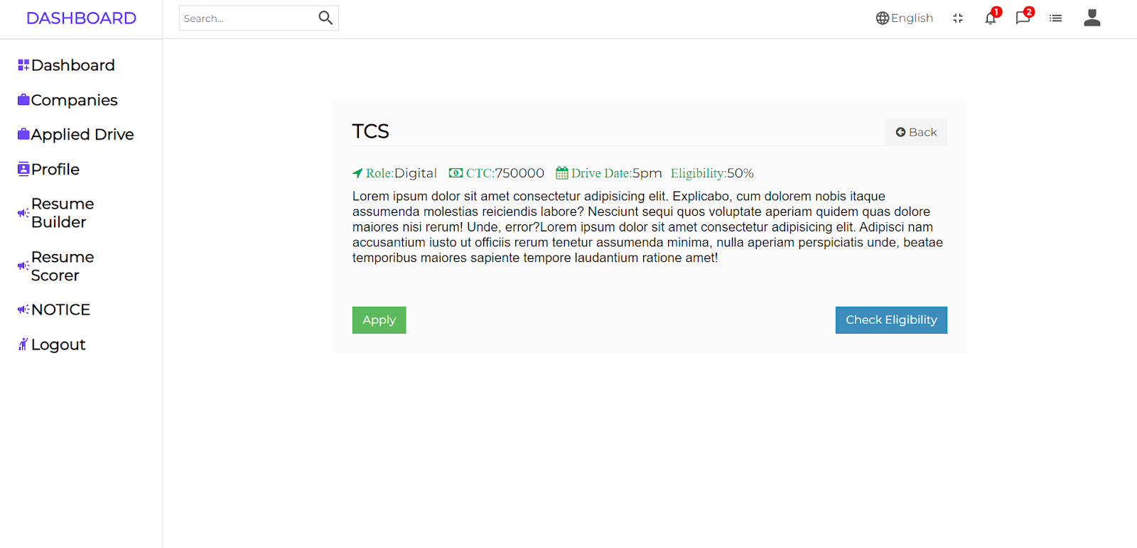

**Fig 7.8** Apply Drive Page

Figure 7.9 shows how a Placement Officer can Post the drive of the company so that students can apply to the company.

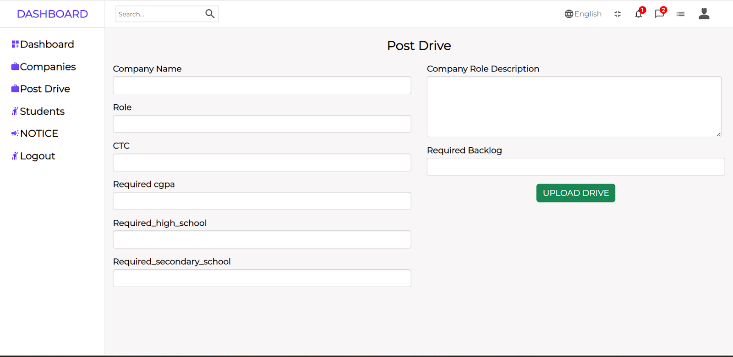

**Fig 7.9** Post Drives

Figure 7.10 shows students present in the database with their profile as well as Placement officers can see to which company he or she has applied.

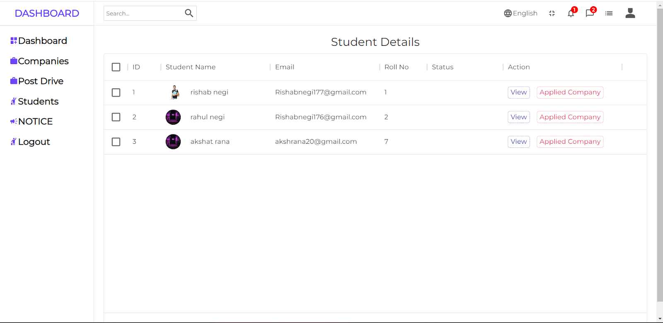

**Fig 7.10** All student Details

Figure 7.11 shows how placement officers can view the posted companies' details. Placement officer can see which students have applied to this company as well as can update if a student gets placed in this company. They can also delete this drive.

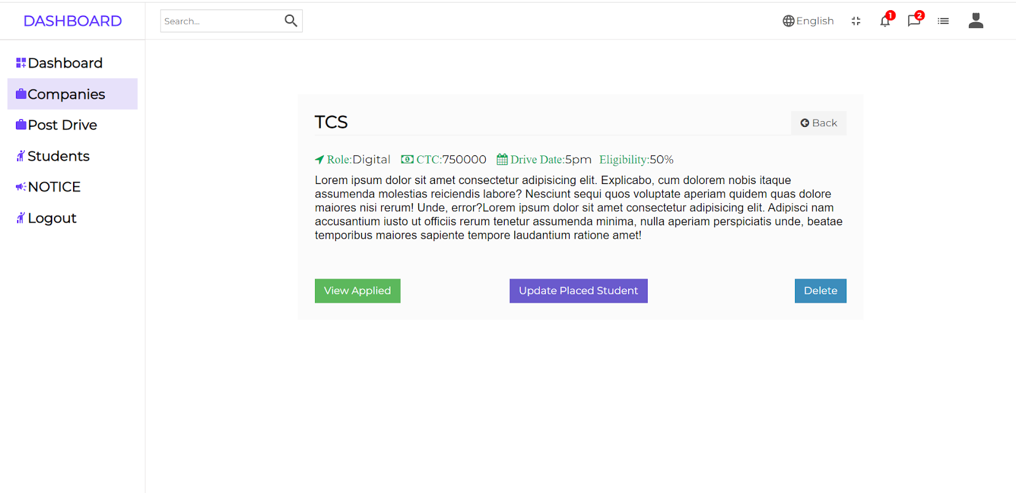**Fig 7.11** Company details

On clicking the view applied button in figure 7.11, the Placement officer can see which student has applied for this company along with the details of that student. Placement officer can download the student applied details in excel format and can pass those details to the respective HR of the Company as shown in figure 7.12.

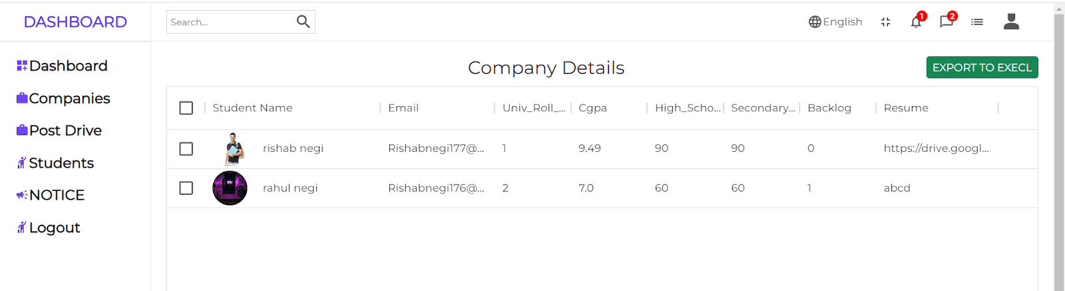

**Fig 7.12** Student applied to company details

On clicking update Placed student button in figure 7.11, Placement officer can mark the student placed for this company by providing email id of student as shown in figure 7.13.

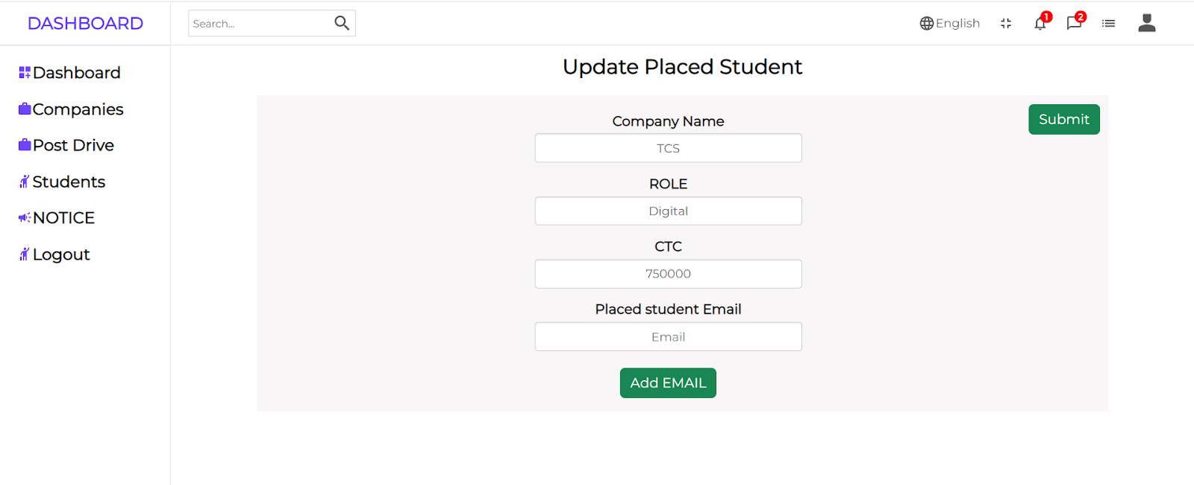

**Fig 7.13** Mark Student Placed for this company

On clicking student placed TPO can see which student is placed to this company.

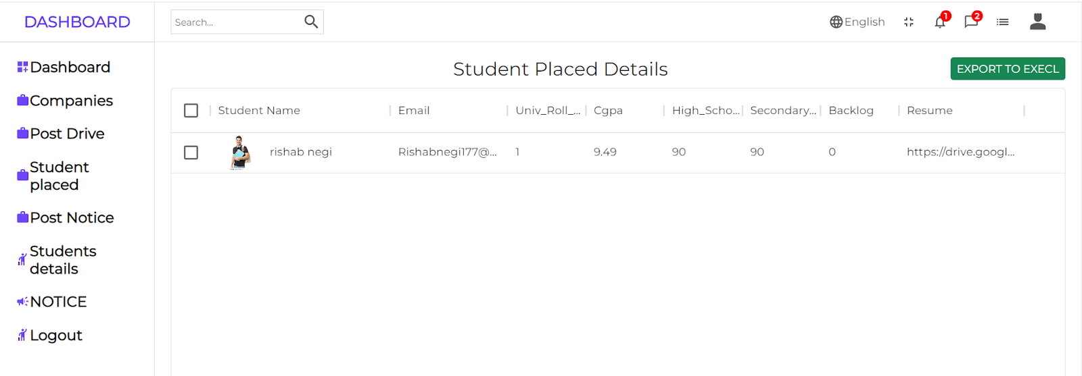

**Fig 7.14** Student placed to xyz company

On uploading a resume to figure 7.7. Resume analyzer will score your resume on different skill sets as shown in figure 7.15

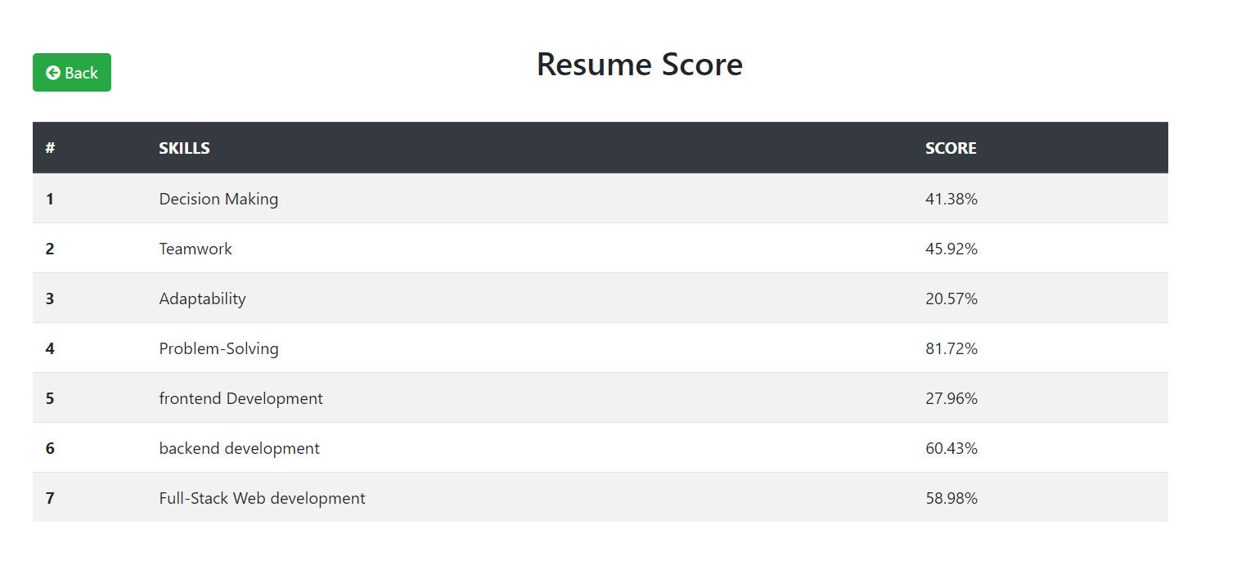

**Fig 7.15** Resume Score

On clicking on the applied company in Figure 7.10 TPO can see which company students have applied as shown in Figure 7.16.

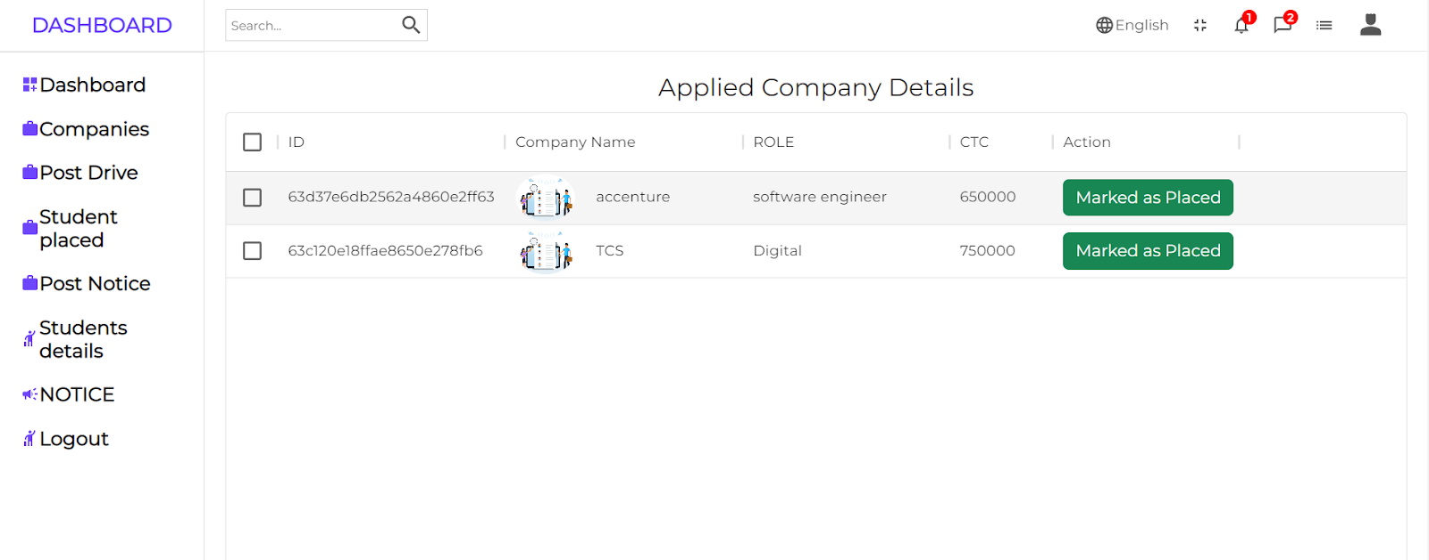

**Fig 7.16** Applied Company Details